651 WI-83, Hartland 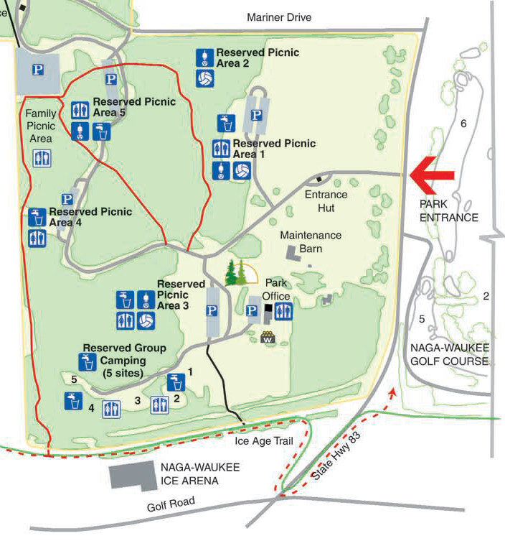 NORTH

Interstate 94

